Electronic III - Project

**Lead Acid Battery Charger (24V, 8A)**

March 2022

Nifla M. N. F. 190413D

Prathapasinghe S. P. 190470X

Sadith W. M. L. 190538N

Vakeesan K. 190643G

Department of Electronic & Telecommunication Engineering

University of Moratuwa

This project proposal is for a lead-acid battery charger with output capabilities of 24V/8A. The proposal mainly focuses on four key areas: Market analysis, Specifications of the product, block diagrams and circuit diagrams, and a rough timeline of the project. Note that the values indicated in circuit diagrams are not precisely calculated, rather, the diagrams are to provide an overall view of each block.

**Marketing Research**

There are some good 24V 8A lead acid battery chargers in the market at present. Some of them include good extra features as well.

1. 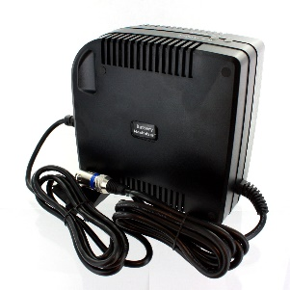Exell Battery Maximizer 24V 8A Mobility Lead-Acid Battery Charger

This product is by Exell batteries. It is fully automatic, efficient, multi stage fully switch charger. It has advanced universal AC input of 100V or 240V. There is function to stopping overcharging the battery as well. Light weight and small size are user friendly feature of the product. It has some protection features for the battery such as reverse polarity protection, over voltage protection and short circuit protection.

Figure : Exell battery maximizer

1. 24V 8A lead acid AGM and Gel Battery Charger with PFC (Power Factor Correction) circuit for mobility scooter power wheelchairs. This product comes under the brand called ‘Power First’. Input voltage can vary from 110V to 250V and output voltage is 24V. This can be used to charge 24V 12AH battery or 50AH. Minimum battery voltage that can be charged is 15V. Charge algorithm of the battery is IUoU(CC/CV/Floating). Some other interesting features of the charger are having boost charge voltage of 28.2V-28.8V and floating charge voltage of 27.2V-27.6V. This product has some protection features as well. This also has short circuit protection and reversed polarity protection. In addition to them it has sparkles protection, AC surge protection, over temperature protection.

Figure : AGM & Gel battery charger

1. 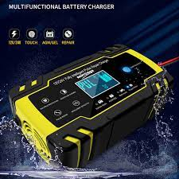12V-24V 8A Fully Automatic Battery-charger Digital LCD Display Car Battery Chargers Power Pulse Repair Chargers Wet Dry Lead Acid. This is a product with intelligent charging, automatic stop when fully charged, one button repair and winter and summer mode charging. There is a microprocessor to control the product. This battery charger can be used to restore drained and sulfated batteries. Charger is very user friendly as it has a touch sensitive display as well. Some protection abilities in this product are polarity protection, output short circuit protection, non-battery link protection, over voltage protection, over temperature protection and many more.

Figure : Fully Automatic battery charger

**Specifications for our product**

* Optimized control for maximum battery capacity and life.
* Internal logic provides three charging states.
* Controls both voltage and current at the output.
* High accuracy achieved in various temperature of the battery.
* Standby supply current can be achieved up to a minimum level (e.g. 1.6 mA).

When battery is shorted, in order to prevent high current charging the output current is limited to low-level until battery reaches a particular voltage(state-1). Low current turn-on mode can be achieved using enable comparator and trickle bias output.

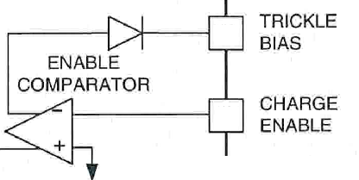

Figure 4: Enable comparator and trickle bias

After that peak current is given to the battery up to 95% of battery voltage(state-2). Then battery goes to the overcharge state and it stops charging by a current sense amplifier. If a load is connected to the battery then the charger contributes its full output to the load. when battery goes beyond 10%, charger will go to its first state.

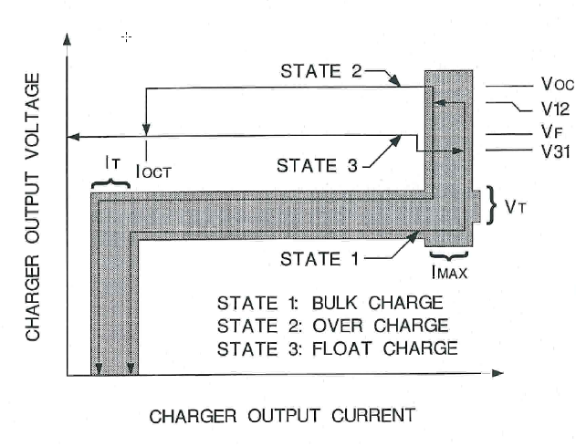

Figure 5: Three states of charging cycle

Even though the battery is fully charged, charger draws certain amount of current in order to maintain the stand-by mode. But we can’t increase it to a higher level then there will be an inefficiency in the charger.in case of maintaining the efficiency at a sufficient level, typically this current will be in Milliamps level. Monitoring the stand-by current at a level (e.g. 1.6mA) will help to avoid changing reference voltages of the Op-amps according to the temperature of the battery. It also helps to avoid sudden current surge to the battery when charger starts its functions again, thus battery will be safe. Furthermore, we can't make a stand-by current to be zero. (If we want we can make a mechanical switch to stop charging when the battery is full.)

**Circuit Design**

Figure 6: Circuit design

AC to DC voltage Convertor

DC voltage Regulator

Voltage Level Indicator

Charging Circuit

Battery

Over Charging Indicator

**AC to DC voltage Convertor**

The purpose of this module is to convert the 230 AC voltage into usable DC voltage. It contains a transformer, bridge rectifier and a filter to get a good DC output.

Figure 7:Sample Circuit for AC/DC Convertor

**DC voltage Regulator**

This module limits the generated DC voltage into DC voltage levels like 24V, 9V that required for various components.

Figure 8:Sample Circuit for DC Regulator

**Charging Circuit**

This module is responsible for charging the battery when its voltage is lower that the required level. This is a feedback control loop module. when battery is fully charged to the required voltage, it will recognize it and indicate it to user.

Figure 9: Sample Circuit for Charging Circuit

**Voltage Level Indicator**

This comparator module indicated the voltage level of the battery according to the feedback of the battery.

Figure 10: Sample Circuit for Battery Level Indicator

**Over charging Indicator**

This module indicates when the battery is over charging. It has a bulb and a small speaker to warn the user about over charging the battery. It is a great safety feature to save the battery lifetime as well as the lifetime of the charger.

The circuit contains the following circuit sections,

1. Zener diode circuit for detecting cutoff terminal voltage of the battery
2. Transistor circuit for operate the relay
3. Diode circuit for back current protection
4. LED (and speaker) indicator circuit for indication of full charging of the battery.

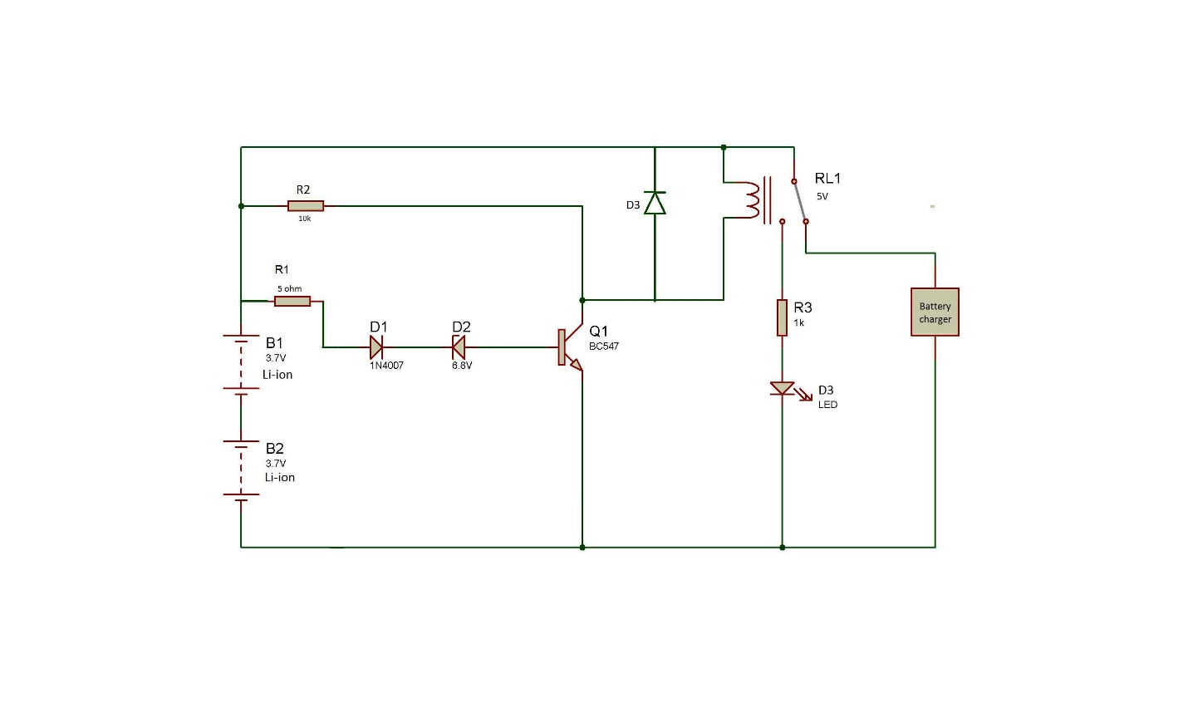

DC level

(cut-off limit)

Figure 11: Sample Circuit for over charge indicator

**Timeline**

* Market survey and project proposal – 13rd March
* Simulation – 30th March
* Prototyping and testing – 20th April
* PCB designing – 28th April
* Enclosure Designing – 5th May